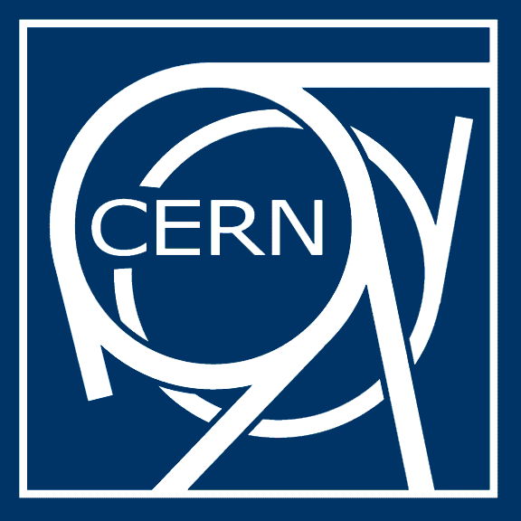
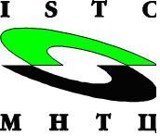

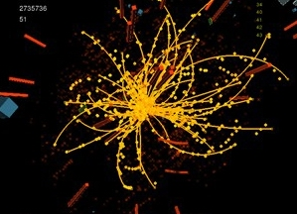
13th CERN-ISTC SAC Seminar
New Perspectives of High Energy Physics
01 – 05 September 2010
BINP, Novosibirsk, Russian Federation

September 1
8:30 | Bus from hotel “Golden Valley” to BINP
8:30 - 9:30 | Registration at the BINP main entrance
9:30 | Opening Session.  Chairs: E. Avrorin (SAC) and S .Bertolucci (CERN)  All sessions will be held in the BINP Conference Hall, 4th floor of main building
9:30 | Welcome Speeches: A. Skrinsky (BINP), J. Sugimoto (SAC Chairman)
9:45 | ISTC Mission. W. Gudowski (ISTC)
10:00 | CERN Programme. R. Heuer (CERN)
10:40 | Particle physics overview and vision. J. Ellis (CERN)
11:20-11:40 | Coffee break
11:40 | HEP at Budker Institute. Y. Tikhonov (BINP)
12:10 | HEP at Protvino/ITEP. A. Zaytsev (IHEP)
12:40 | Group photo on the stairs of BINP main entrance
13:00-14:30 | Lunch (BINP Canteen)
14:30 | Large Cern and other HEP Projects and with ISTC support.  Chairs: JP Contzen (SAC) and R. Heuer (CERN)
14:30 | Linac -4. M. Vretenar (CERN) and A. Tribendis (BINP)
15:00 | Prospects of the ATLAS Experiment at the LHC. O.L. Fedin (PNPI, Gatchina, St-Petersburg)
15:30 | CMS Overview: CMS detector operation performance and overview of first physics from LHC, Teresa Rodrigo (Instituto de Fisica de Cantabria, Santander, Spain)
16:00 | Status of the LHCb detector. Vladimir Obraztsov (IHEP Protvino)
16:30-16:45 | Coffe Break
16:45 | NA48 and successor experiments: Study of Charged Kaon Rare Decays at CERN SPS. V. Kekelidze (JINR)
17:25 | Astrophysics - a Univer's own High Energy. J. Ellis (CERN)
18:10 | Bus to hotel “Golden Valley”
18:20 | one bus from hotel “Golden Valley” to Restaurant “Scientific House”  another one bus from BINP to Restaurant “Scientific House”
18:30 | Cocktail Reception in the Restaurant “Scientific House”
 | After Reception – by walk 750 meters to Hotel “Golden Valley”
September 2
9:00 | Bus from hotel “Golden Valley” to BINP
9:30 | Challenges in nuclear and heavy ion physics.  Chairs: Y. Sugimoto(SAC) and Yu. Tikhonov (BINP)
9:30 | The Present and Future RHIC Program at Brookhaven National Laboratory. P.Steinberg (BNL)
10:00 | Particle physics program at J-PARC. T. Kobayashi (KEK)
10:30 | NICA project in Dubna. G. Trubnikov (JINR)
11:00-11:20 | Coffee break
11:20 | Extreme Field Physics with Lasers and Highly-Charged Heavy Ions. T.Kuehl (GSI)
11:50 | Subatomic Physics Underway in Canada. W. Trischuk (IPP)
12:20 | The International Linear Collider: Status and Prospects. B. Barish (GDEILC)
12:50-14:00 | Lunch (BINP Canteen)
14:00 | Applications and knowledge transfer.  Chairs: A. Syrota (SAC) and P. Steinberg (BNL)
14:00-16:00 | Medical application of hadrons and heavy ions
14:00 | Hadrontherapy with protons and carbone ions in France, research program and status of existing and scheduled clinical facilities. J. Remillieux (IPN-Etoile)
14:30 | Chiba program in Japan. E. Takada (NIRS)
15:00 | Medical Applications of Hadrons and Heavy-Ions: US Program. J. Alonso (LBL)
15:30 | The Canadian hadron experience and possibilities for the future. T. Pickles (BCC)
16:00-16:30 | Coffee Break
16:30 –18:00 | Poster Session
18:00 | Concert of singers “Markell’s voices” (http://www.markells.ru/)  (in the BINP Conference Hall)
19:30 | Cocktail Reception in the BINP Canteen
21:00 | Bus from BINP Canteen to Hotel
September 3
9:00 | Bus from hotel “Golden Valley” to BINP
9:30 | Future projects/technologies & Data handling challenges.  Chairs: A.Zaytsev (IHEP) and T. Kurtyka (CERN)
9:30 | CLIC concept. J-P. Delahaye (CERN)
10:00 | Colliders with Crab-waist collision scheme. E. Levichev (BINP)
10:20 | Super Tau Charm Factory Project. P. Piminov (BINP)
10:40 | VEPP-2000 - new electron-positron collider at BINP. Y. Shatunov (BINP)
11:00 | Interaction region of super c-tau factory. A. Bogomyagkov (BINP)
11:15-11:30 | Coffee break
11:30 | New electronics for Belle II electromagnetic calorimeter. V.Zhulanov (BINP)
 | LHC detector upgrade plans
11:50 | ATLAS upgrade for sLHC. A.Cheplakov (JINR)
12:10 | ATLAS tracker upgrade: Silicon Strip Detectors for the sLHC. S. Burdin
12:30 | Spanning from Acquisition to Grid. L. Mapelli (CERN)
13:00-14:30 | Lunch (BINP Canteen)
14:30 | pp physics at LHC detectors and physics related talks.  Chairs: U. Rohatgi (SAC) and P. Jenni (CERN)
14:30 | LHCb calorimeter system operation. D. Savrina (ITEP)
14:50 | The alignment of the CMS silicon tracker. J. Tomaszewska (DESY)
15:10 | Production of Heavy Flavor and Photons on High-Energy Collides, and Rare Decays of Heavy Mesons, O.Korchyn (NSC KIPT)
15:30 | Construction and performance of the ATLAS TRT. V. Myalkovsky (JINR)
15:50-16:10 | Coffee break
16:10 | TRT tracker with first collisions at LHC. S. Smirnov (MIPhI)
16:40 | ALICE talk . A.Kurepin (INR RAS)
17:10-17:40 | ATLAS sensitivity to left-right symmetry at 7 TeV. K. Skovpen (BINP)
18:00 | Buses to hotel “Golden Valley” and then to Restaurant “Borvikha”
19:00 | Banquet in the Restaurant “Borvikha”
22:30 | Bus from Restaurant “Borvikha” to Hotel
September 4
9:00 | Bus from hotel “Golden Valley” to BINP
9:30 - 11:00 | Young scientists competition.  Chair: JP Contzen (SAC) and A.Skrinsky (BINP)
9:30 - 11:00 | 9 selected presentation * 10 min  - Maxim Bryzgunov (BINP). Low energy proton storage ring with longitudinal magnetic field and electron cooling.  - Yaroslav Getmanov (BINP). Electron injection into a cyclic accelerator using laser wakefield acceleration.  - Alexander Gramolin (BINP). Proton form factors and two-photon exchange contribution to elastic electron-proton scattering.  - Fedor Ignatov (BINP). The hadronic cross-sections measurements at VEPP-2M and VEPP-2000 e+e- colliders.  - Alexander Rudenko (BINP). Can CP-violation be observed in heavy-ion collisions?  - Alexandr Zaytsev (BINP). System Administration of ATLAS TDAQ Computing Environment.  - Sergey Kostromin (JINR). Beam dynamics in accelerators for medical applications: from calculations to machine performance.  - Alexey Anisyonkov (BINP). ATLAS Grid Information System.  - Leonid Ephstein (BINP) CMD-3 Liquid Xenon Calorimeter.
11:00-11:30 | Poster Session Wrap-up.
11:30-12:00 | Award of the Best Young Scientists Presentations
12:00-13:00 | Wrap-up and Conclusions of the Conference. J-P. Contzen (SAC) and P. Jenni (CERN)
 | Conclusions for ISTC future strategy. W. Gudowski (ISTC)
13:00-14:30 | Lunch
14:30 | Social events:  buses to Geological Museum and Museum of Railway
September 5 | Technical visits
9:00 | Bus from hotel “Golden Valley” to BINP
9:30 | Technical visit to Budker Institute

